HTML/CSS Day 5 Knowledge Test

  - What tag is used for external links? (write out the complete tag with any attributes)

  - What tag creates list with a predefined style of bullet points?

  - Write out the main HTML tags that make up the skeleton of every website.

  - What is the purpose of the head tag?

  - What area of the HTML page should you link in your CSS?

  - How are websites made responsive?

  - What is the selector used in CSS to embed/declare custom fonts?

  - What is the purpose of a webkit?

  - Name all the webkit prefixes and the browsers that they support.

  - Name a benefit of using the Mobile first development approach?

  - What part of the systems development lifecycle (SDLC) have we been practicing for most of this week?

  - What is the next stage after the analysis stage in the SDLC?

  - What does HTML stand for?

  - What does CSS stand for?

  - Write an example of a pseudo selector.

  - Explain how the CSS position attributes relative and absolute can be used together.

  - How can I access the li elements within CSS?

<nav>

<ul >
<li><a href="#home">Home</a></li>
<li><a href="#products">Products</a></li>
<li><a href="#products">Products</a></li>
</ul>
</nav>

Part 2

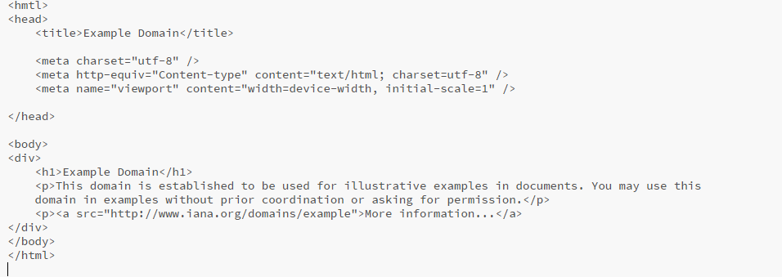
- Spot the errors in the following code.

- There are approximately 3-4

- What 3 languages make up the web development trifecta?

- What tag ensures that text is displayed as bold/important in HTML?

- Which of the following indicates an end tag?
- / * < @ “ !

- Write the required HTML code that would insert an image.

Part 3

- How is a comment written in CSS?

- What declaration allows you to change the color of the background?

- Name a class selector and an ID selector.

- What is the default attribute for the position property?

- Write the following with the correct naming convention –

Class=” test class”

- Write code for a basic CSS animation (changing background color for example).

- When applied to a div what’s the result of the following code?
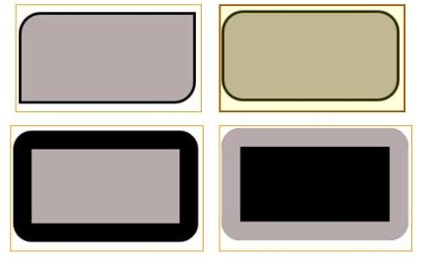
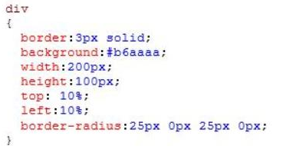

- Sort the following in order of priority highest to lowest –
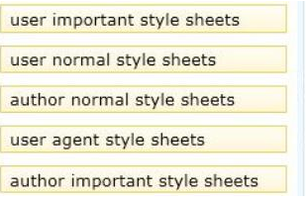

- Write what is required from the text-shadow property and what is optional?

Text-shadow:

- Write a media query for the screen size of 480px and above.

- Which two of the following code snippets will add transparency of 50% to the element?
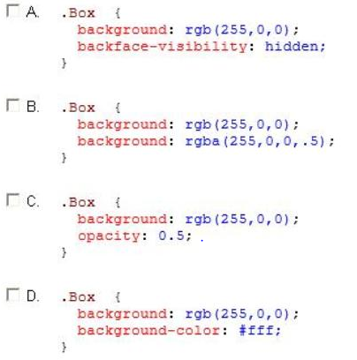

- Add the correct tag to the following so that it is optimised for screen readers and search engine optimisation. The reader must be able to recognise it as being part of the navigation
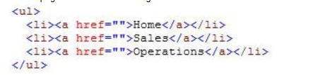

- Select the correct tags for the below code.

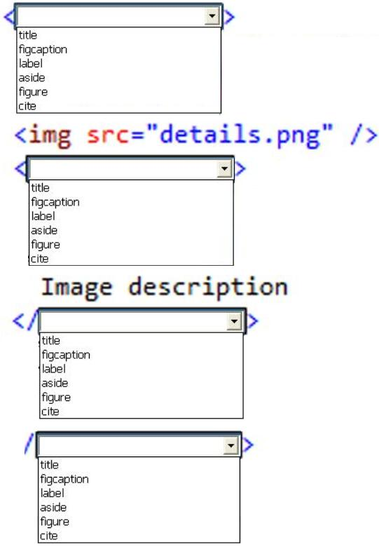

- What flex property enables its children to take the full width of the screen?

- You are developing an HTML5 web application and are styling text.
You need to use the text-transform CSS property.
Which value is valid for the text-transform property?
A. Italic
B. Line-through
C. Capitalize
D. 20px

- You are developing an HTML5 web application and are styling text.
You need to use the text-transform CSS property.
Which value is valid for the text-transform property?
A. Lowercase
B. Blink
C. Line-through
D. 20px

